- SCOPE

The specific purpose for this Work Instruction is to provide step by step instructions on data entry using the input tool. For more additional information/details on the CSSP input tool, view the ‘Basic functionalities of the CSSP Water Quality Input Tool’ WI (005_W7).

- REFERENCES

WI: Creating sampling plans with CSSP Web tools.
WI: Basic functionalities of the CSSP Water Quality Input Tool (005_W7)

- PROCEDURE – Full version with Lab QA/QC

3.1 If not already done, install the CSSP water quality input tool using the setup.exe on the shared drive (Shellfish\CSSP_Code\CSSPWQInputTool_Install).

3.2 Create a sampling plan if not already done (see WI ‘Creating sampling plans with CSSP Web Tools’). This step can only be done by a supervisor or biologist.

3.3 Open the CSSP water quality input tool. The first screen of the input tool will asks you to open a sampling plan file. Click on ‘open sampling plan’ and load the appropriate sampling plan .txt file that you want to input data in (should be located under your computers C drive (C:CSSPLabSheets). After the sampling plan file is loaded, another directory will be created with the year found in the sampling plan .txt file (i.e. C:CSSPLabSheets\Name of Sampling plan file\Year of sampling plan). All Lab Sheets will be saved under the appropriate year directory.

3.4 You will be prompted to input your initials. This will be used in the log to track who has made changes to every data sheets. Next you need to enter your approval code if you are a supervisor that has approval authority for data sheets. If you do not have this code (ex: summer staff), skip this box. Next you need to enter a code which will have been setup by EC staff (in the sampling plan) and should be different for each contractor/lab and year. Once the sampling plan file and code is selected, the application will look like below if you are using the full version (with lab QA/QC’s included). If you are using the light version, see section 4.4 (the light version doesn’t not have the ‘approval code’ section as the approval is done directly on the lab data sheets).

Note: from almost anywhere, clicking on a specific box/field and then pressing F1 will show a bit of help text in the status bar at the bottom.

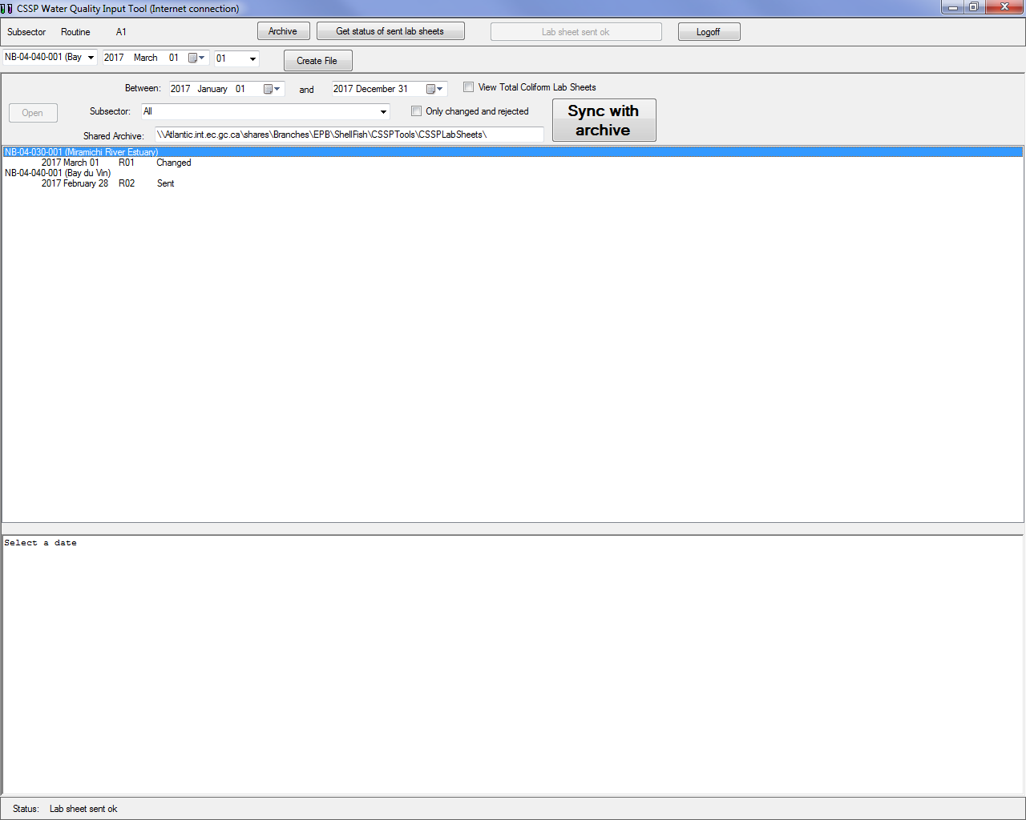

3.5 You should ALWAYS click on the large ‘Sync with Archive’ button before starting any other work in the input tool to ensure that you are working on the latest versions of the data sheets.

3.6 If you want to finish a data sheet that you had previously started, find it in the list (you can use the sorting functions by subsector and/or date or the ‘only changed and rejected’ check box) and complete any fields required. Data sheets that haven’t been sent to the server since last changed will have a comment ‘changed’ next to their date. You should always click the ‘Get Status of Sent Lab Sheets’ button at the top to update the information next to each data sheet.

3.7 To enter a new data sheet, select the appropriate sub-sector from the drop box (second row), then select the sampling date and then change the Run number if
the particular run you want to enter is not the first one for that subsector/date. Click on ‘Create File’. Your new screen will look like:

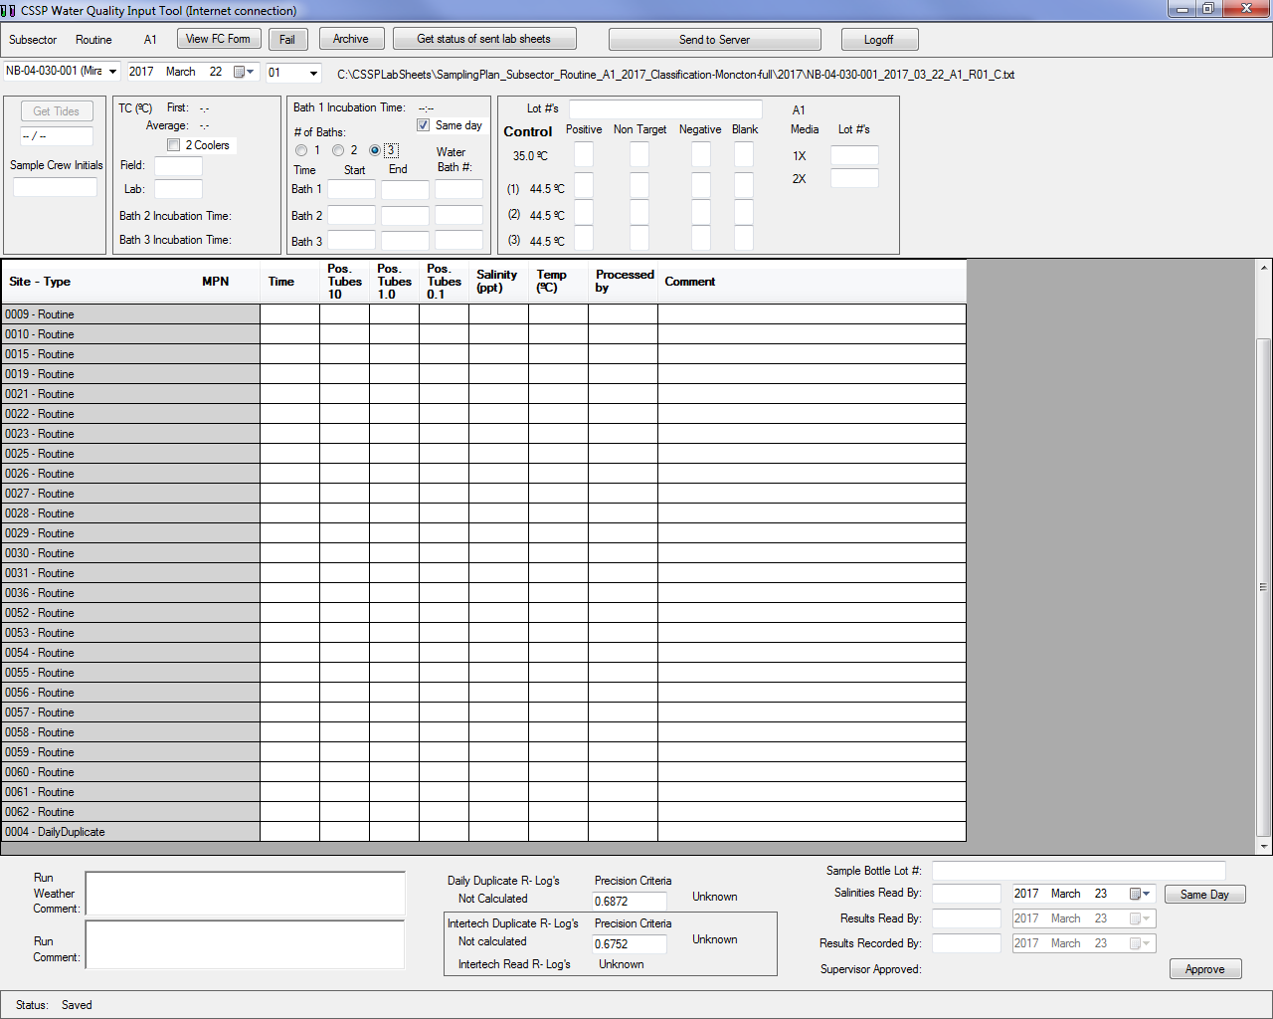

3.8 Enter all the required information at the top of the data sheet. Using the ‘tab’ key on the keyboard will move you to the next required field. The required information includes:

- Sampling crew initials
- Field TC and lab TC (click on the ‘2 coolers’ check box if you used two coolers and have extra TC’s values to enter).

- Start and end time of incubation (only uncheck the ‘same day’ box if you are processing your samples on the next day after sampling. You need supervisor approval prior to processing samples on the next day and will need to enter appropriate comments in the ‘run comment’ section. If you have samples in more than one bath, select the appropriate number and fill in the start and end time for those.
- Water bath ID for all baths.
- Control lot number and control results including the blanks.
- Media lot numbers.

The information you’ve entered will be saved automatically. You can decide to enter some of this information (data in field book for instance) at a later time. Every time you enter or change information in a data field, there will be a log (time and date stamp) associated with your initials (under archive button). If you change data from a field, the box will change to blue to indicate to the user that there was a change made. User can then refer back to the archive to find the original values that were changed along with the information of who did the change and when it was done. If you decide to only enter part of the information now and finish later, you should always click on Archive, then on the large ‘Sync with Archive’ button to send the data sheet on the server in case someone else needs to enter data on that same datasheet from a different computer.

* If someone worked on a data sheet and inputted salinities (for example) while you were entering sampling times and temperatures on the same sheet on a different computer, whoever would have sent the data to the archive last would have overridden the first persons data (salinity data would have been lost). To prevent two users from editing the same data sheet at the same time from two different computers and overwriting each other’s data, a new feature has been put in place.

- If you either try to send to the server a data sheet for acceptance or sync with archive and there is already a data sheet there with the same subsector and the same date, the input tool will open a new screen that shows the two data sets. The different data will be highlighted in red and you will have to either copy this information (copy the ‘sender/red’ information over the ‘receiver’ information) over the old information (receiver) or not (skip). Pressing cancel will cancel the archive sync or ‘send to server’ process while pressing ‘skip’ will not copy over the sender data and go to the next data sheet that needs to be addressed. It is very important to verify the two data sheets to insure that no data is lost by overriding a previous version.

3.9 Next you need to enter the time, positive tube results, salinity, temperature, initials of person who processed the sample and any relevant comments for each sampling station if applicable.

Lastly you need to enter the positive tube results for the duplicate if one was processed (time, salinity, temperature and processed by initials will be filled in automatically using the original sample information). The duplicate will default to a pre-selected station but can be changed if needed directly in the input tool by selecting the appropriate site and pressing F2. The log value for the duplicate will automatically be calculated (bottom left) once you enter positive tube results. The input tool will also flag whether or not the duplicate was acceptable or not acceptable by comparing it to the Precision Criteria (unique to each lab and automatically imputed, do not change the value of the Precision Criteria unless instructed to do so).

If you have a monthly InterTech duplicate and/or an InterTech reading test to enter, click on the appropriate sampling station and then press F3 to create an additional line for the InterTech duplicate OR F4 to create an additional line for the InterTech reading. If you made a mistake and need to delete this additional line, select the original sampling station again and repress on F3 or F4 and a prompt will ask you if you would like to delete this particular InterTech dup/reading.

Note: The input tool will substitute automatically the MPN value for a sampling station if the duplicate or inter-tech duplicate result has higher MPN value for that station. This is done once the data sheet is sent to the server (Web Tools).

Note: Pressing the ‘tab’ key on your keyboard will move you from right to left in a row and pressing the up and down arrows will move you up and down in a column.

You can also skip the time, salinity and temp boxes if you are reading samples and have not yet had the chance to gather that information. Data sheets that have not been completed cannot and shouldn’t be sent to the server for biologist acceptance unless appropriate comments explaining why the information is missing is present (example: temperature for some sampling stations not available because thermometer broke in the field).

3.10 Only when all the information for the ‘time’ fields have been entered will you be able to click on the ‘get tides’ button on the top left. This will automatically calculate the start and end tide based on the tide tables that have been pre-selected for that
subsector. If for any reason you want to change the tides, you can do so in the text box underneath the ‘get tides’ button by double clicking that box.

3.11 Next you need to fill in information on the bottom right of the screen.

- Bottle lot number
- Salinities read by and date (defaults to 24 hrs after sampling but you can click on ‘Same Day’ button if you have a field salinity meter).

- Results read by.
- Results recorded by.

  - Lastly, you need to record any field weather notes or other run or lab comments in the appropriate sections at the bottom.

3.13 Review all the information entered for any error or typos. The input tool will automatically flag (in red) any QC’s that are non-conforming or errors such as time typos (not using 24 hr. clock), positive tube/MPN index errors (entering an impossible combination). Once all the information is entered and reviewed you may log off. The lab supervisor will then long on and input their ‘Approval Code’, review the data sheet and click on the ‘approve’ button at the bottom. Only then will the ‘send to server’ button at the top of the screen (you need to have an internet connection to do this) will allow you to send the information for biologist acceptance. If critical information is missing such as control results, pos. tube result box empty, etc., an error message will be displayed instead of the ‘send to server’ button indicating what information is missing. If nothing is missing the information will be sent to the server and the biologist will be alerted that a new data sheet is available for acceptance or rejection. If you need to make a correction to a data sheet that is in ‘sent’ or ‘accepted’ status, the input tool will prompt you with a pop up to make sure you really want to make a change and to remind the user to RESEND to server and to RE-synch with the archive. At this point your work is done unless the biologist rejects the data sheet and gives you additional information.

3.14 Once you are finished, make sure to click on ‘Archive’ and then on the large ‘Sync with Archive’ to send a backup of your data on the Shellfish drive. This will enable any user access to the most up to date versions of all the available datasheets as
well as the sampling plan files. *See last note at 3.8 if you have already sent this data sheet to the server or to the archive.

- PROCEDURE – Light version (i.e.: no lab QA/QC’s)

4.1 Follow the steps outlined in section 3.1 to 3.7 (at step 3.7 your application should look like below:

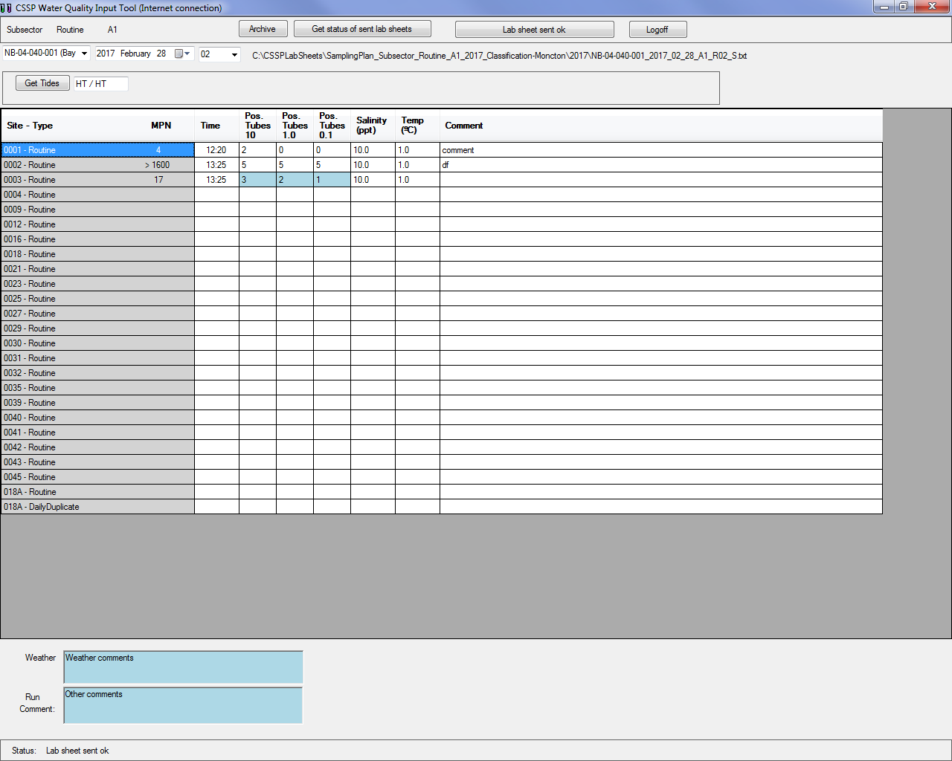

4.2 Next you need to enter the time, positive tube results, salinity, temperature and any relevant comments for each sampling station if applicable.

Lastly you need to enter the positive tube results for the duplicate if one was processed (time, salinity and temperature will be filled in automatically using the original sample information). The duplicate will default to a pre-selected station but can be changed if needed directly in the input tool by selecting the appropriate site and pressing F2.

If you have a monthly InterTech duplicate to enter, click on the appropriate sampling station and then press F3 to create an additional line for the InterTech duplicate OR F4 to create an additional line for the InterTech reading. If you made a mistake and need to delete this additional line, select the original sampling station again and repress on F3 or F4 and a prompt will ask you if you would like to delete this particular InterTech dup/reading.

*Note: The input tool will substitute automatically the MPN value for a sampling station if the duplicate or inter-tech duplicate result has a higher MPN value for that station. This is done once the data sheet is sent to the server (Web Tools).

You can also skip the time, salinity and temp boxes if you are reading samples and have not yet had the chance to gather that information. Data sheets that have not been completed cannot and shouldn’t be sent to the server for biologist acceptance unless appropriate comments explain why the information is missing is present (example: temperature for some sampling stations not available because thermometer broke in the field).

4.3 Only when all the information for the ‘time’ fields have been entered will you be able to click on the ‘get tides’ button on the top left. This will automatically calculate the start and end tide based on the tide tables that have been pre-selected for that
subsector. If for any reason you want to change the tides, you can do so in the text box underneath the ‘get tides’ button by double clicking that box.

4.4 Lastly, you need to record any field weather notes or other run or lab comments in the appropriate sections at the bottom.

4.5 The information you’ve entered will be saved automatically. You can decide to enter some of this information (data in field book for instance) at a later time. Every time you enter or change information in a data field, there will be a log (time and date stamp) associated with your initials (under archive button). If you change data from a field, the box will change to blue to indicate to the user that there was a change made. User can then refer back to the archive to find the original values that were changed along with the information of who did the change and when it was done. If you decide to only enter part of the information now and finish later, you should always click on Archive, then on the large ‘Sync with Archive’ button to send the data sheet on the server in case someone else needs to enter data on that same datasheet from a different computer.

* If someone worked on a data sheet and inputted salinities (for example) while you were entering sampling times and temperatures on the same sheet on a different computer, whoever would have sent the data to the archive last would have overridden the first persons data (salinity data would have been lost). To prevent two users from editing the same data sheet at the same time from two different computers and overwriting each other’s data, a new feature has been put in place.

- If you either try to send to server a data sheet for acceptance or sync with archive and there is already a data sheet there with the same subsector and the same date, the input tool will open a new screen that shows the two data sets. The different data will be highlighted in red and you will have to either copy this

information (copy the ‘sender/red’ information over the ‘receiver’ information) over the old information (receiver) or not (skip). Pressing cancel will cancel the archive sync or ‘send to server’ process while pressing ‘skip’ will not copy over the sender data and go to the next data sheet that needs to be addressed. It is very important to verify the two data sheets to insure that no data is lost by overriding a previous version.

4.6 Review all the information entered for any error or typos. The input tool will automatically flag (in red) any errors such as time typos (not using 24 hr. clock), positive tube/MPN index errors (entering an impossible combination). Once all the information is entered and reviewed click on the ‘send to server’ button at the top of the screen (you need to have an internet connection to do this). If critical information is missing, an error message will be displayed instead of the ‘send to server’ button indicating what information is missing. If nothing is missing the information will be sent to the server and the biologist will be alerted that a new data sheet is available for acceptance or rejection. If you need to make a correction to a data sheet that is in ‘sent’ or ‘accepted’ status, the input tool will prompt you with a pop up to make sure you really want to make a change and to remind the user to RESEND to server and to RE-synch with the archive. At this point your work is done unless the biologist rejects the data sheet and gives you additional information.

4.7 Once you are finished, make sure to click on ‘Archive’ and then on the large ‘Sync with Archive’ to send a backup of your data on the Shellfish drive. This will enable any user access to the most up to date versions of all the available datasheets as well as the sampling plan files. *See last note at 4.5 if you have already sent this data sheet to the server or to the archive.

- MAINTENANCE/TROUBLESHOOTING

-If for whatever reason an error occurred while reading the sampling plan file, the status bar at the bottom of the application will indicate the line number and the error.

-If for some reason you need to delete or modify a data field, select the appropriate cell and press F2 or double click on the cell. If the sampling date is the cell you want to modify, pressing F2 will open a separate box that will allow you to change the date. If the date of the data sheet is changed, the old data with the old date will be stored in the ‘’not used’ folder under your CSSP folder in case the wrong data sheet was modified. Whenever you make changes to a data sheet that was previously sent to the server, you need to re-send it to the server so it can be accepted by the biologist. The new sheet will override the previous one in the database. When you change data in any data field, the field will change to a blue background. This indicates to the user that the data has been changed and they can refer to the data log to see what the change was, when it was done and by whom.

-If you need to delete and entire data sheet/field run, you will need to go in your CSSPLabsheets folder under my document and find/delete it from your 2017 (or appropriate year) folder. You will also need to delete if from the Shellfish back up drive if
you had previously synced your archive with the server. Deleting a data sheet from the my document CSSP folder will remove it from the input tool list but if it was already sent to the server, it will need to be deleted in the Web tools as well. See ‘Basic functionalities of the CSSP Web Tools’ for instructions on how to delete a data sheet from the data base. This should only be done by a biologist or designated staff.

-If an unusual tube combination is entered in the input tool, an error message in red will appear instead of the MPN value. If a user tries to send this to the server, a pop up box will ask if the user is certain. This will ensure that staff double checks for any typos before sending the information to the server. If the user is sure and sends the data to the server for biologist acceptance, the biologist will have a flag at the acceptance stage in the web tools. Biologist will either reject the data sheet and ask the lab staff to assign a value in the input tool as well as a comment with the original tube combination and resend to server OR biologist will accept the data sheet and no data for that sampling station on that date will be recorded in the database.

-For any additional troubleshooting help (errors or bugs), please contact Charles LeBlanc (Charles.leblanc@ec.gc.ca). For general questions, contact your local CSSP working group committee member.

